APPIUM :

Webdriver+Mobile Features=Appium  
  
Appium is an open source, cross-platform test automation tool for native, hybrid and mobile web apps, tested on simulators (iOS, FirefoxOS), emulators (Android), and real devices (iOS, Android, FirefoxOS).TO WRITE APPIUM CODE , WE NEED APPIUM CLIENT(WE CAN WRITE IN DIFFERENT LANGUAGES SUCH AS JAVA,PYTHON ETC WITH THEIR RESPECTIVE JAR CLIENTS) AND APPIUM SERVER.

WHEN WE WRITE CODE USING JAVA, THEN JAVA CLIENT JARS WILL COMMUNICATE WITH APPIUM SERVER AND EXECUTE TEST CASES IN YOUR RESPECTIVE MOBILES.

Supported Platforms

* iOS
* Android
* FirefoxOS

Why Appium?

1. You don't have to recompile your app or modify it in any way, due to use of standard automation APIs on all platforms.
2. You can use any testing framework.
3. You can write the code in any language Supported by Webdriver
4. If you use Apple's UIAutomation library without Appium you can only write tests using JavaScript and you can only run tests through the Instruments application. Similarly, with Google's UiAutomator you can only write tests in Java. Appium opens up the possibility of true cross-platform native mobile automation.

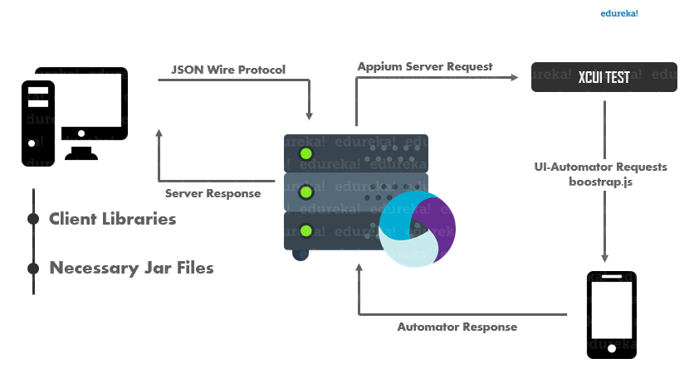

**APPIUM INSTALLATION ON WINDOWS FOR ANDROID AUTOMATION:**

* INSTALL JAVA JDK AND ANDROID STUDIO.
* SET ENVIRONMENT VARIABLES FOR JAVA: JAVA_HOME AND FOR JAVA PATH : BIN LOCATION
* SET ENVIRONMENT VARIABLES FOR ANDROID STUDIO : FROM c:\Users\username\AppData\Local\**Android**\**Sdk** SETUP ANDROID_HOME, BIN PATH, TOOLS PATH, PLATFORM TOOLS PATH.
* DOWNLOAD AND SETUP ANDROID EMULATOR TO RUN AND TEST THE ANDROID APPS.
* RUN THE EMULATOR FROM CMD PROMPT USING THE COMMAND : COPY EMULATOR PATH FROM c:\Users\username\AppData\Local\**Android**\**Sdk.**

GO TO COMMND PROMPT AND TYPE CD c:\Users\username\AppData\Local\**Android**\**Sdk/EMULATOR->HIT ENTER**

AND THEN TYPE -> EMULATOR AVD (“YOUR EMULATOR NAME”)->HIT ENTER

* WE GET NODE MODULES(SUCH AS APPIUM,ANGULAR JS OR PROTRACTOR NODE MODULES) IN TO THE SYSTEM, WE HAVE TO INSTALL NODE.JS SOFTWARE. SETUP ENVIROMENT VARIABLES FOR NODE_HOME AND BIN PATH AS WELL.
* APPIUM SERVER COMES AS A NODE MODULE. THESE NODE MODULES CAN BE DOWNLOADED VIA NPM ONLY. GO TO COMMAND PROMPT AND USE “NPN INSTALL -G APPIUM” COMMAND AND HIT ENTER. THEN NPM COMMUNICATES WITH NODE SERVER AND INSTALLS APPIUM NODE MODULES IN OUR SYSTEM GLOBALLY (-G).
* WHEN APPIUM SERVER GETS STARTED IN CMD PROMPT, HIT CTRL+C AND IT ASKS FOR YOU TO EXIT (Y/N); HIT Y TO STOP SERVER. THEN AGAIN HIT APPIUM COMMAND TO START SERVER.
* DOWNLOAD JAVA CLIENT LIBRARIES FROM APPIUM.IO AND IT REDIRECTS TO MAVEN.
* DOWNLOAD ECLIPSE AND OPEN NEW JAVA PROJECT. IMPORT APPIUM JAVA JAR FILES AND SELENIUM JAVA JAR FILES IN TO THE PROJECT BY -> RIGHT ON PROJECT->PROPERTIES-> JAVA BUILD PATH-> LIBRARIES-> ADD EXTERNAL JARS-> ADD THE DOWNLOADED APPIUM JAVA CLIENT JARS AND SELENIUM JAVA JAR FILES.

**APPIUM INSTALLATION ON MAC FOR IOS AUTOMATION:**

* DOWNLOAD XCODE FROM IOS STORE AND INSTALL IT.
* RUN XCODE AND CREATE A NEW PROJECT AND CHECK FOR IOS EMULATOR IF ITS WORKING.
* DOWNLOAD ECLIPSE AND JAVA JDK AND SET UP THE ENVIRONMENT VARIABLES.
* DOWNLOAD APPIUM AND SELENIUM JAVA CLAND IENT JARS FROM GOOGLE AND IMPORT APPIUM JAVA JAR FILES AND SELENIUM JAVA JAR FILES IN TO THE PROJECT BY -> RIGHT ON PROJECT->PROPERTIES-> JAVA BUILD PATH-> LIBRARIES-> ADD EXTERNAL JARS-> ADD THE DOWNLOADED APPIUM JAVA CLIENT JARS AND SELENIUM JAVA JAR FILES.

**WRITING APPIUM TESTCASES IN ANDROID USING WINDOWS:**

* FIRST START APPIUM SERVER FROM CMD PROMPT.
* START ANDROID EMULATOR
* WRITER ANDROID CAPABILITIES AND TEST CASES IN ECLIPSE USING JAVA.

**DESIRED CAPABILITIES FOR ANDROID:-**

|  |
| --- |
| DesiredCapabilities cap= new DesiredCapabilities();   cap.setCapability(MobileCapabilityType.DEVICE_NAME, "YOUR OWN EMULATOR NAME");  capabilities.setCapability(MobileCapabilityType.AUTOMATION_NAME,"uiautomator2");//new step   capabilities.setCapability(MobileCapabilityType.APP, app.getAbsolutePath()); |

**CODE FOR RUNNING APK FILE IN ANDROID EMULATOR :**

|  |
| --- |
| import java.io.File;  import java.net.MalformedURLException;  import java.net.URL;  import java.util.concurrent.TimeUnit;  import org.openqa.selenium.remote.DesiredCapabilities;  import io.appium.java_client.android.AndroidDriver;  import io.appium.java_client.android.AndroidElement;  import io.appium.java_client.remote.MobileCapabilityType;  public class base {  public static AndroidDriver<AndroidElement> capabilities() throws MalformedURLException  {  // TODO Auto-generated method stub  File appDir = new File("src");  File app = new File(appDir, "ApiDemos-debug.apk");  DesiredCapabilities capabilities = new DesiredCapabilities();    capabilities.setCapability(MobileCapabilityType.DEVICE_NAME, "Rahulemulator");  capabilities.setCapability(MobileCapabilityType.APP, app.getAbsolutePath());  AndroidDriver<AndroidElement> driver = new AndroidDriver<>(new URL("http://127.0.0.1:4723/wd/hub"), capabilities);    return driver;  }      } |

**USING ANDROID UIAUTOMATOR VIEWER FOR INSPECTING ELEMENTS IN ANDROID DEVICE:-**



OPEN ANDROID SDK/BIN FOLDER AND WE CAN FIND UIAUTOMATOR VIEWER APP. LAUNCH THIS APP WHEN EMULATOR IS ALREADY RUNNING AND APPIUM SERVER IS CONNECTED. THEN HIT SCREENSHOT AND YOU CAN GET THE EMULATOR SCREEN WHICH CAN BE FURTHER USED FOR INSPECTING ELEMENTS. YOU CAN TAKE ALL THE RESPECTIVE SCREENSHOTS ACCORDINGLY TO FIND ELEMENTS.

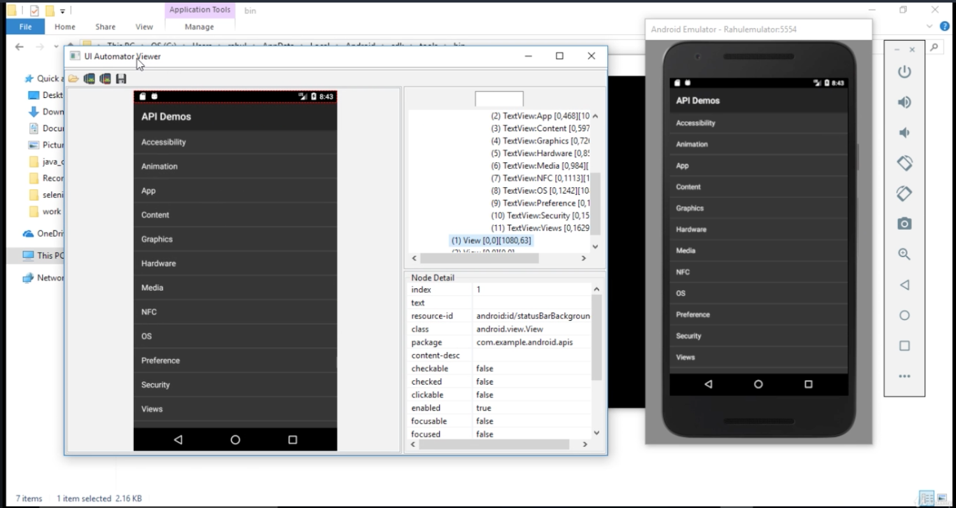



**NATIVE APPS : USING ANDROID:**

**AUTOMATING APP UI USING XPATHS  
AND TEXT ATTRIBUTES:**

IN ANDROID UI AUTOMATOR WE CAN FIND THE ATTRIBUTES OF AN ANDROID APP SUCH AS ID,CLASS NAME, XPATH

XPATH SYNTAX:

//TAGNAME[@ATTRIBUTE=’VALUE’] WHERE CLASSNAME CAN ACT AS TAG NAME

IF THE TAGNAME IS UNIQUE FOR BOTH XPATHS,THEN USUALLY SERVER SELECTS THE FIRST ONE BY DEFAULT. BUT IF WE WANT THE 2ND XPATH. USE [2] AFTER THE TAGNAME SUCH AS (//TAGNAME)[2].

|  |
| --- |
| @Test  public void test() throws MalformedURLException {  File appDir = new File("src");    File app = new File(appDir, "bookMyShow-ucb.apk");  DesiredCapabilities cap=new DesiredCapabilities();  cap.setCapability(MobileCapabilityType.PLATFORM_NAME,MobilePlatform.ANDROID);  cap.setCapability(MobileCapabilityType.DEVICE_NAME, "Android emulator");    cap.setCapability(MobileCapabilityType.NEW_COMMAND_TIMEOUT, "100");  cap.setCapability(MobileCapabilityType.APP, app.getAbsolutePath());  AndroidDriver driver=new AndroidDriver(new URL("http://127.0.0.1:4723/wd/hub"),cap );  //driver.findElementById("com.bt.bms:id/btnLogin").click();  driver.findElementById("com.bt.bms:id/btnSignUp").click();  int s=driver.findElements(By.className("android.widget.EditText")).size();  System.out.println(s);  List<WebElement>a=driver.findElements(By.className("android.widget.EditText"));  a.get(0).sendKeys("Appium");  a.get(1).sendKeys("Mobile");  a.get(2).sendKeys("appium@training");  a.get(3).sendKeys("password");  driver.findElementById("com.bt.bms:id/action_icon").click(); |

**APPIUM API'S FOR UI INTERACTION WITH  
ID'S AND CLASSNAMES:**

|  |
| --- |
| @Test  public void test() throws MalformedURLException {  File appDir = new File("src");    File app = new File(appDir, "ApiDemos-debug.apk");  DesiredCapabilities cap=new DesiredCapabilities();  cap.setCapability(MobileCapabilityType.PLATFORM_NAME,MobilePlatform.ANDROID);  cap.setCapability(MobileCapabilityType.DEVICE_NAME, "Android Emulator");    cap.setCapability(MobileCapabilityType.NEW_COMMAND_TIMEOUT, "20");  cap.setCapability(MobileCapabilityType.APP, app.getAbsolutePath());  AndroidDriver driver=new AndroidDriver(new URL("http://127.0.0.1:4723/wd/hub"),cap );    driver.scrollTo("Preference").click();  List <WebElement>b=driver.findElements(By.id("android:id/text1"));  System.out.println(b.get(8).getText()); |

**HANDLING MULTIPLE SIMILAR OBJECTS OF APPS WITH INDEXES:**

IF THE TAGNAME IS UNIQUE FOR BOTH XPATHS,THEN USUALLY SERVER SELECTS THE FIRST ONE BY DEFAULT. BUT IF WE WANT THE 2ND XPATH. USE [2] AFTER THE TAGNAME SUCH AS (//TAGNAME)[2]. (* HERE [2] THIS IS THE INDEX)

|  |
| --- |
| import java.io.File;  import java.net.MalformedURLException;  import java.net.URL;  import java.util.concurrent.TimeUnit;  import org.openqa.selenium.remote.DesiredCapabilities;  import io.appium.java_client.android.AndroidDriver;  import io.appium.java_client.android.AndroidElement;  import io.appium.java_client.remote.MobileCapabilityType;  public class basics extends base{  public static void main(String[] args) throws MalformedURLException {  // TODO Auto-generated method stub      AndroidDriver<AndroidElement> driver=capabilities();  driver.manage().timeouts().implicitlyWait(10, TimeUnit.SECONDS);    //xpath id className, androidUIautomator  /* xpath Syntax  * //tagName[@attribute='value']    *  */  driver.findElementByXPath("//android.widget.TextView[@text='Preference']").click();  driver.findElementByXPath("//android.widget.TextView[@text='3. Preference dependencies']").click();  driver.findElementById("android:id/checkbox").click();  driver.findElementByXPath("(//android.widget.RelativeLayout)[2]").click();  driver.findElementByClassName("android.widget.EditText").sendKeys("hello");  driver.findElementsByClassName("android.widget.Button").get(1).click();  }  } |

**ANDROIDUIAUTOMATOR USAGE IN IDENTIFYING OBJECTS OF APPS:**

|  |
| --- |
| import java.net.MalformedURLException;  import java.util.concurrent.TimeUnit;  import io.appium.java_client.android.AndroidDriver;  import io.appium.java_client.android.AndroidElement;  public class Uiautomaortest extends base {  public static void main(String[] args) throws MalformedURLException {  // TODO Auto-generated method stub  AndroidDriver<AndroidElement> driver=capabilities();  driver.manage().timeouts().implicitlyWait(10, TimeUnit.SECONDS);  // driver.findElementByAndroidUIAutomator("attribute("value")")    driver.findElementByAndroidUIAutomator("text(\"Views\")").click();    // driver.findElementByAndroidUIAutomator("text(\"Views\")").click();    // Validate clickable feature for all options  // driver.findElementsByAndroidUIAutomator("new UiSelector().property(value)");  System.out.println(driver.findElementsByAndroidUIAutomator("new UiSelector().clickable(true)").size());    }  } |

**TOUCH ACTIONS IN APPIUM (GESTURES AUTOMATION -1):**

|  |
| --- |
| @Test  public void test() throws MalformedURLException, InterruptedException {  File appDir = new File("src");    File app = new File(appDir, "ApiDemos-debug.apk");  DesiredCapabilities cap=new DesiredCapabilities();  cap.setCapability(MobileCapabilityType.PLATFORM_NAME,MobilePlatform.ANDROID);  cap.setCapability(MobileCapabilityType.DEVICE_NAME, "Android Emulator");    cap.setCapability(MobileCapabilityType.NEW_COMMAND_TIMEOUT, "200");  cap.setCapability(MobileCapabilityType.APP, app.getAbsolutePath());  AndroidDriver driver=new AndroidDriver(new URL("http://127.0.0.1:4723/wd/hub"),cap );    System.out.println(driver.isLocked());//LOcked condition  System.out.println(driver.getContext());  List<WebElement> abc=driver.findElements(By.className("android.widget.TextView"));    TouchAction t=new TouchAction(driver);  t.tap(abc.get(2)).perform();  //TouchAction t1=new TouchAction(driver).longPress(el);        //driver.installApp("");  driver.closeApp();    //driver.currentActivity();  //driver.context(name)  //driver.zoom(el); |

**TAPPING AND LONGPRESS EVENTS (GESTURES AUTOMATION -2):**

FOR GETTING ADDITIONAL TAP OPTIONS IN TAP OPTIONS METHOD WE HAVE TO ADD ADDITIONAL STATEMENT IN THE CLASS FILE AS SHOWN BELOW :

IMPORT STATIC IO.APPIUM.JAVA_CLIENT.TOUCH.TAPOPTIONS.TAPOPTIONS;

**TOUCH ACTIONS SEQUENCE EXECUTION:**

|  |
| --- |
| import java.net.MalformedURLException;  import java.util.concurrent.TimeUnit;  import org.openqa.selenium.WebElement;  import io.appium.java_client.TouchAction;  import static io.appium.java_client.touch.TapOptions.tapOptions;  import static io.appium.java_client.touch.LongPressOptions.longPressOptions;  import io.appium.java_client.android.AndroidDriver;  import io.appium.java_client.android.AndroidElement;  import static java.time.Duration.ofSeconds;  import static io.appium.java_client.touch.offset.ElementOption.element;  public class gestures extends base {  public static void main(String[] args) throws MalformedURLException {  // TODO Auto-generated method stub  AndroidDriver<AndroidElement> driver=capabilities();  driver.manage().timeouts().implicitlyWait(10, TimeUnit.SECONDS);  driver.findElementByXPath("//android.widget.TextView[@text='Views']").click();  //Tap  TouchAction t =new TouchAction(driver);  WebElement expandList= driver.findElementByXPath("//android.widget.TextView[@text='Expandable Lists']");  t.tap(tapOptions().withElement(element(expandList))).perform();  driver.findElementByXPath("//android.widget.TextView[@text='1. Custom Adapter']").click();  WebElement pn= driver.findElementByXPath("//android.widget.TextView[@text='People Names']");    t.longPress(longPressOptions().withElement(element(pn)).withDuration(ofSeconds(2))).release().perform();  //Thread.sleep(2000);  System.out.println(driver.findElementById("android:id/title").isDisplayed());    }  } |

**STRATEGY FOR AUTOMATING SWIPPING EVENT(GESTURES AUTOMATION -3):**

|  |
| --- |
| @Test  public void test() throws MalformedURLException, InterruptedException {  File appDir = new File("src");    File app = new File(appDir, "cal_debug.apk");  DesiredCapabilities cap=new DesiredCapabilities();  cap.setCapability(MobileCapabilityType.PLATFORM_NAME,MobilePlatform.ANDROID);  cap.setCapability(MobileCapabilityType.DEVICE_NAME, "Android Emulator");      cap.setCapability(MobileCapabilityType.NEW_COMMAND_TIMEOUT, "200");  cap.setCapability(MobileCapabilityType.APP, app.getAbsolutePath());  AndroidDriver driver=new AndroidDriver(new URL("http://127.0.0.1:4723/wd/hub"),cap );  driver.findElementById("com.calculator:id/EditText01").sendKeys("50");  driver.sendKeyEvent(AndroidKeyCode.HOME);  driver.findElementById("com.calculator:id/EditText02").sendKeys("50");    driver.findElementByAndroidUIAutomator("new UiSelector().text(\"Multiply\")").click();  System.out.println(driver.findElementById("com.calculator:id/TextView01").getText());    } |

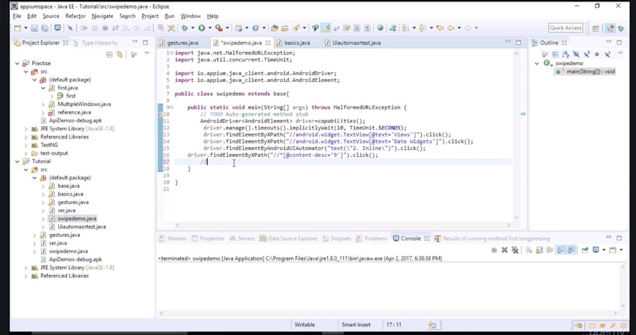

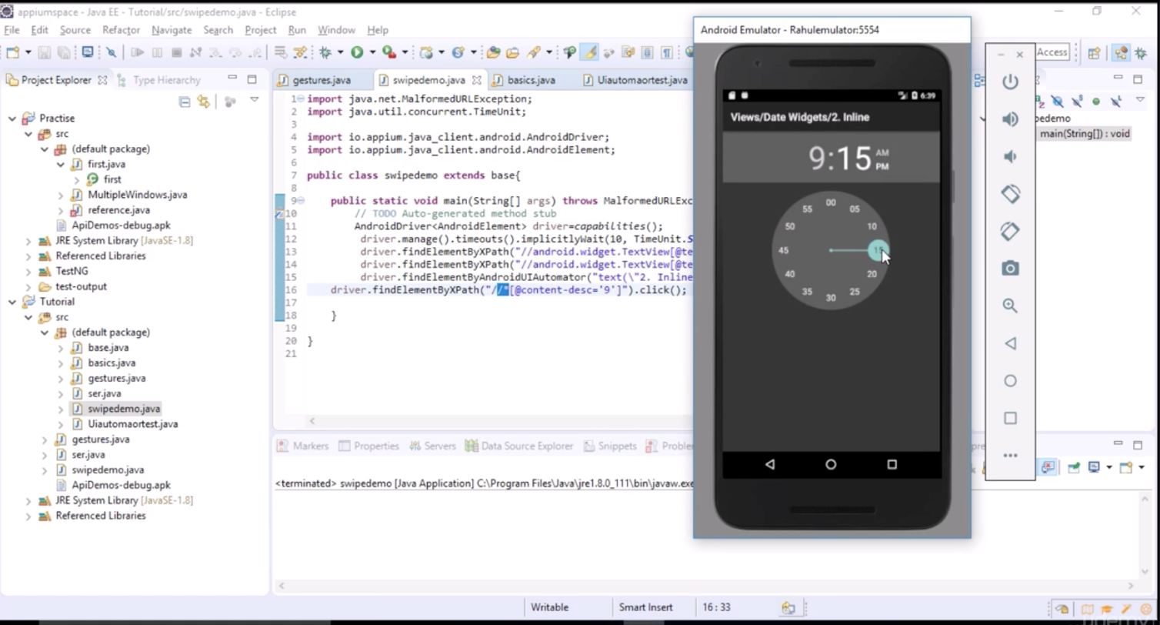

**ADVANCED GESTURES  
AUTOMATION WITH KEY EVENTS HANDLING:**

**DEMO ON SWIPPING THE CLOCK-  
PRACTISE EXERCISES:**

|  |
| --- |
| import java.net.MalformedURLException;  import java.util.concurrent.TimeUnit;  import org.openqa.selenium.WebElement;  import static io.appium.java_client.touch.LongPressOptions.longPressOptions;  import io.appium.java_client.TouchAction;  import io.appium.java_client.android.AndroidDriver;  import io.appium.java_client.android.AndroidElement;  import static java.time.Duration.ofSeconds;  import static io.appium.java_client.touch.offset.ElementOption.element;  public class swipedemo extends base{  public static void main(String[] args) throws MalformedURLException {  // TODO Auto-generated method stub  AndroidDriver<AndroidElement> driver=capabilities();  driver.manage().timeouts().implicitlyWait(10, TimeUnit.SECONDS);  driver.findElementByXPath("//android.widget.TextView[@text='Views']").click();  driver.findElementByXPath("//android.widget.TextView[@text='Date Widgets']").click();  driver.findElementByAndroidUIAutomator("text(\"2. Inline\")").click();  driver.findElementByXPath("//*[@content-desc='9']").click();  TouchAction t=new TouchAction(driver);  //long press //on element// 2 sec// move to another element and you release  WebElement first=driver.findElementByXPath("//*[@content-desc='15']");  WebElement second=driver.findElementByXPath("//*[@content-desc='45']");    t.longPress(longPressOptions().withElement(element(first)).withDuration(ofSeconds(2))).moveTo(element(second)).release().perform();  }  } |

**HOW TO AUTOMATE SCROLLING? GESTURES AUTOMATION -5:**

|  |
| --- |
| import java.net.MalformedURLException;  import java.util.concurrent.TimeUnit;  import io.appium.java_client.android.AndroidDriver;  import io.appium.java_client.android.AndroidElement;  public class scrollingDemo extends base{  public static void main(String[] args) throws MalformedURLException {  // TODO Auto-generated method stub  AndroidDriver<AndroidElement> driver=capabilities();  driver.manage().timeouts().implicitlyWait(10, TimeUnit.SECONDS);  driver.findElementByXPath("//android.widget.TextView[@text='Views']").click();  driver.findElementByAndroidUIAutomator("new UiScrollable(new UiSelector()).scrollIntoView(text(\"WebView\"));");    }  } |

HERE new UiScrollable(new UiSelector() IS AN ANDROID API CODE AND IS NOT A APPIUM CODE. APPIUM DID NOT PROVIDE ANY CODE FOR SCRILLABLE.

**DRAG AND DROP ON NATIVE APPS WITH APPIUM (GESTURE AUTOMATION -6):**

|  |
| --- |
| import java.net.MalformedURLException;  import java.util.concurrent.TimeUnit;  import org.openqa.selenium.WebElement;  import io.appium.java_client.TouchAction;  import io.appium.java_client.android.AndroidDriver;  import io.appium.java_client.android.AndroidElement;  import static io.appium.java_client.touch.LongPressOptions.longPressOptions;  import static io.appium.java_client.touch.offset.ElementOption.element;  public class DragDropdemo extends base{    public static void main(String[] args) throws MalformedURLException {  // TODO Auto-generated method stub  AndroidDriver<AndroidElement> driver=capabilities();  driver.manage().timeouts().implicitlyWait(10, TimeUnit.SECONDS);    driver.findElementByXPath("//android.widget.TextView[@text='Views']").click();  driver.findElementByXPath("//android.widget.TextView[@text='Drag and Drop']").click();  WebElement source=driver.findElementsByClassName("android.view.View").get(0);  WebElement destination=driver.findElementsByClassName("android.view.View").get(1);      TouchAction t = new TouchAction(driver);  //longpress(source)/move(destination)//release  // t.longPress(longPressOptions().withElement(element(source))).moveTo(element(destination)).release().perform();  t.longPress(element(source)).moveTo(element(destination)).release().perform();  }  } |

**Miscelleanous key Events handling with Appium:**

|  |
| --- |
| import java.net.MalformedURLException;  import java.util.concurrent.TimeUnit;  import io.appium.java_client.android.AndroidDriver;  import io.appium.java_client.android.AndroidElement;  import io.appium.java_client.android.AndroidKeyCode;  public class miscelleanous extends base {  public static void main(String[] args) throws MalformedURLException {  // TODO Auto-generated method stub  AndroidDriver<AndroidElement> driver=capabilities();  driver.manage().timeouts().implicitlyWait(10, TimeUnit.SECONDS);  System.out.println(driver.currentActivity());  System.out.println(driver.getContext());  //views - Native , Hybrid, Webview  System.out.println(driver.getOrientation());  System.out.println(driver.isLocked());  // driver.hideKeyboard();  driver.findElementByXPath("//android.widget.TextView[@text='Views']").click();  driver.pressKeyCode(AndroidKeyCode.BACK);  }  } |

**INVOKING APP WITH PACKAGE ACTIVITY:**

IF WE ALREADY HAVE A ANDROID APP INSTALLED ON OUR ANDROID DEVICE AND WE DONOT HAVE A APK FILE OR LOCATION TO LOG IN TO THE CLASS FILE , THEN GO TO -> PLAYSTORE->INSTALL APK INFO-> ->OPEN THE APP-CLICK ON VIEW ALL APPS->SELECT WHICH APP INFO YOU NEED->COPY PACKAGE NAME AND MAIN ACTIVITY NAME AND ADD INTO YOUR CODE.

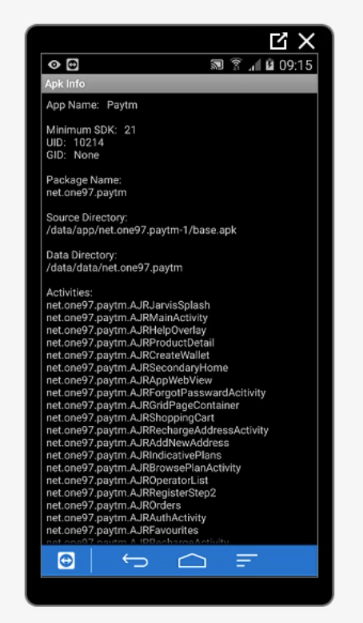

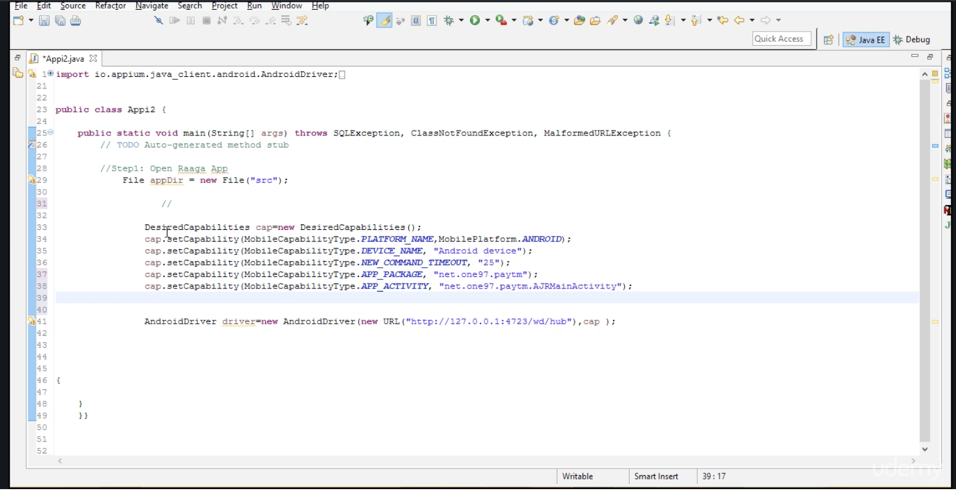

**Web APPS Automation:**

**Configuring Real device to system  
for running Appium Tests:**

CONNECT REAL ANDROID USING ->On devices, which are version 4.2 and higher, to enable “USB Debugging” follow these steps:

1. *Settings > About Phone > Build number > Tap it 7 times to become developer*
2. *Settings > Developer Options > USB Debugging*

GO TO CMD PROMPT AND TYPE ADB DEVICES -> ENTER. THEN IT SHOWS LIST OF DEVICES CONNECT TO PC. IF DONOT FIND YOUR REAL DEVICE, THEN INSTALL DRIVERS FOR WINDOWS USING GOOGLE.

**EXERCISES ON REAL DEVICE-NATIVE  
APPS AUTOMATION:**

|  |
| --- |
| Desired capabilities for Real device Execution  import java.io.File; import java.net.MalformedURLException; import java.net.URL; import java.util.concurrent.TimeUnit;  import org.openqa.selenium.remote.DesiredCapabilities;  import io.appium.java_client.android.AndroidDriver; import io.appium.java_client.android.AndroidElement; import io.appium.java_client.remote.MobileCapabilityType;  public class Recycle3 { public static  AndroidDriver<AndroidElement> capabilities(String device) throws MalformedURLException {  AndroidDriver<AndroidElement>  driver;  // TODO Auto-generated method stub File appDir = new File("src");      File app = new File(appDir, "ApiDemos-debug.apk");      DesiredCapabilities capabilities = new DesiredCapabilities();            //capabilities.setCapability(MobileCapabilityType.DEVICE_NAME, "Rahulemulator");      if(device.equals("real"))      capabilities.setCapability(MobileCapabilityType.DEVICE_NAME, "Android Device");      else          capabilities.setCapability(MobileCapabilityType.DEVICE_NAME, "Rahulemulator");    //  capabilities.setCapability(MobileCapabilityType.BROWSER_NAME, "chrome");     capabilities.setCapability(MobileCapabilityType.APP, app.getAbsolutePath());     driver = new AndroidDriver<>(new URL("http://127.0.0.1:4723/wd/hub"), capabilities);        return driver; }  }    IF YOU ARE USING REAL DEVICE, SET IT AS REAL IN CODE OR ELSE SET AS EMULATOR. |

MOBILE BROWSER CONFIGURATION SETUP FOR APPIUM TESTS:

|  |
| --- |
| Code for Mobile Browser capabilities  import java.io.File; import java.net.MalformedURLException; import java.net.URL; import java.util.concurrent.TimeUnit;  import org.openqa.selenium.remote.DesiredCapabilities;  import io.appium.java_client.android.AndroidDriver; import io.appium.java_client.android.AndroidElement; import io.appium.java_client.remote.MobileCapabilityType;public class baseChrome { public static  AndroidDriver<AndroidElement> capabilities() throws MalformedURLException {  AndroidDriver<AndroidElement>  driver;  // TODO Auto-generated method stub /* File appDir = new File("src");      File app = new File(appDir, "ApiDemos-debug.apk");*/      DesiredCapabilities capabilities = new DesiredCapabilities();           capabilities.setCapability(MobileCapabilityType.DEVICE_NAME, "Android Device");   capabilities.setCapability(MobileCapabilityType.BROWSER_NAME,"Chrome");     //   capabilities.setCapability(MobileCapabilityType.APP, app.getAbsolutePath());     driver = new AndroidDriver<>(new URL("http://127.0.0.1:4723/wd/hub"), capabilities);        return driver; }  } |

AUTOMATING THE CHROME MOBILE BROWSER:

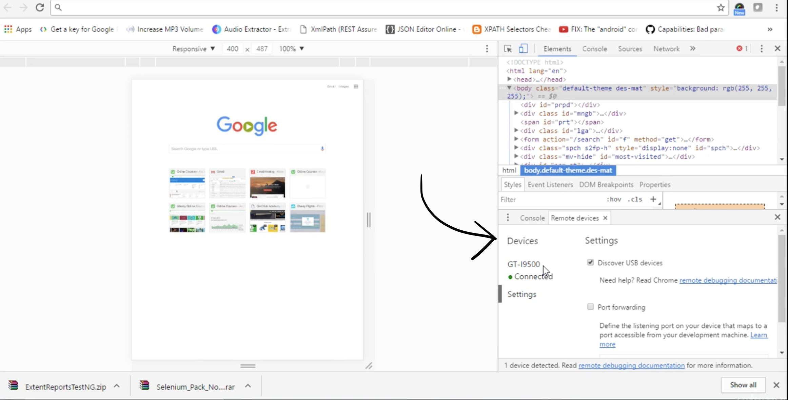

CHECK IF THE DEVICE IS PROPERLY CONNECTED.

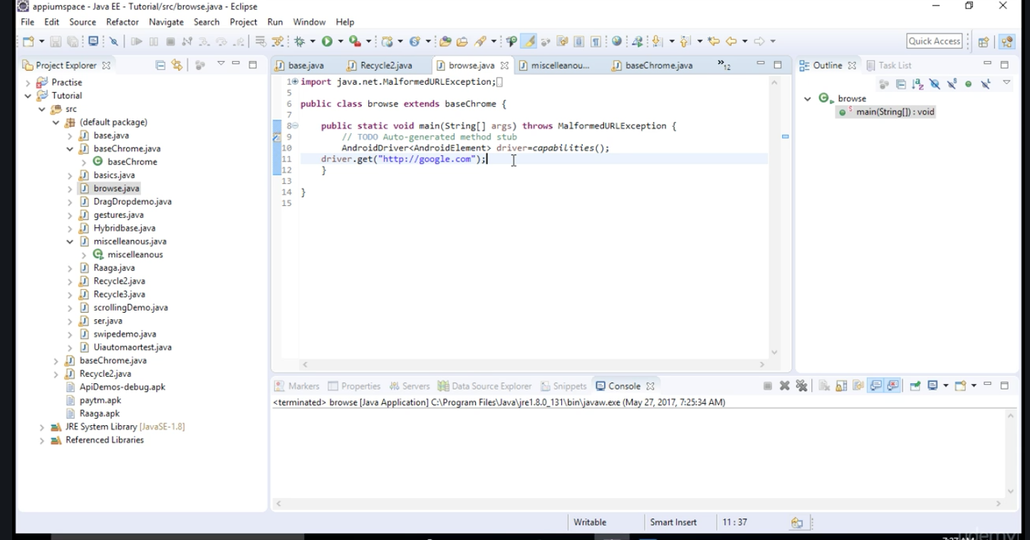

SIMILARLY OPEN FACEBOOK.COM USING THE ABOVE CODE AND RIGHT CLICK ON EMAIL AND RIGHT CLICK-> INSPECT ELEMENT AND SELECT COPY XPATH->

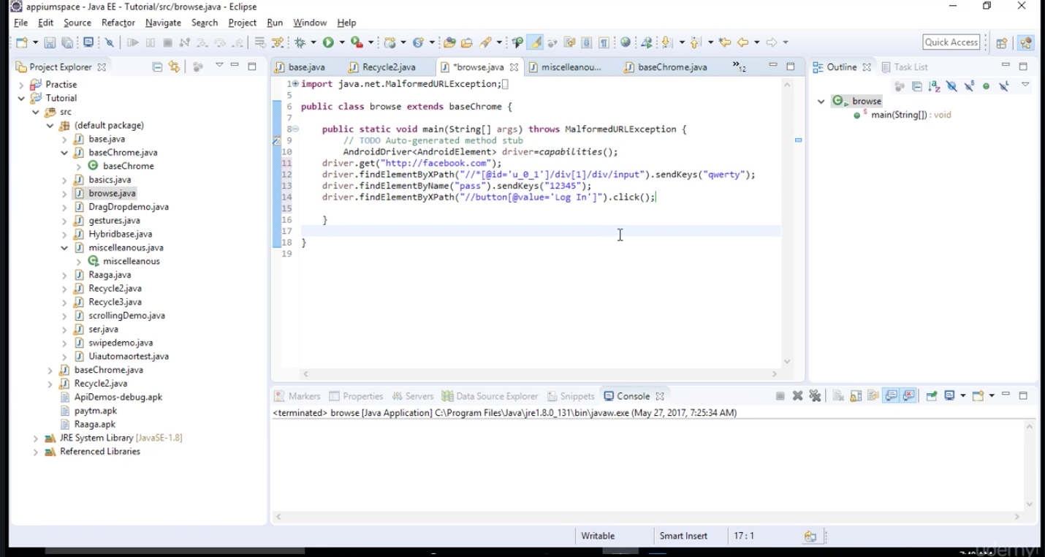

BY THIS CODE YOU CAN OPEN FACEBOOK AND SIGNIN USING THOSE CREDENTIALS.

YOU CAN USE XPATH, ID , CLASSNAME TO AUTOMATE THE TESTS BOTH IN MOBILE CHROME AND WEB.

**EXERCISE MOBILE BROWSER AUTOMATION-1:**

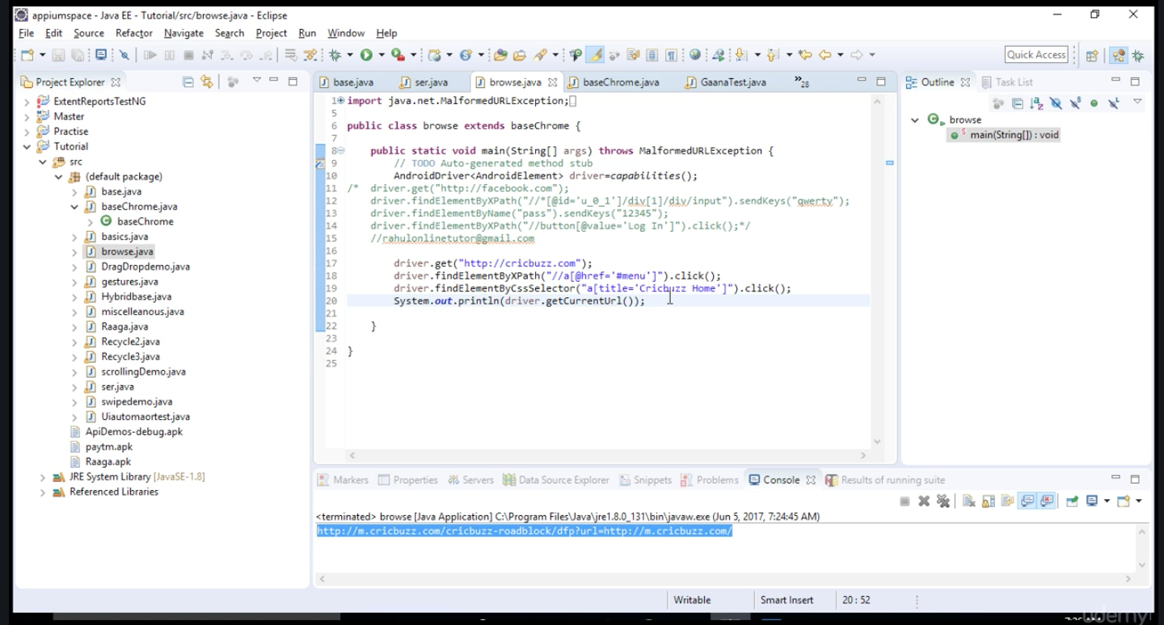

**EXERCISE MOBILE BROWSER AUTOMATION-1:**

IN THE CODE YOUU SEE XPATH,CLASS NAME,ID ARE FOUND USING INSPECT ELEMENT FROM CHROME BROWSER.

IF YOUR ADB DEVICE IS NOT FOUND IN CMD PROMPT THEN HIT THESE 3 CMDS TO GET YOUR CONNECTED DEVICES IN PC,

ADB KILL-SERVER

ADB-START SERVER

ADB DEVICES

|  |
| --- |
| code download  import java.net.MalformedURLException;  import org.junit.Assert; import org.openqa.selenium.By; import org.openqa.selenium.JavascriptExecutor;  import io.appium.java_client.android.AndroidDriver; import io.appium.java_client.android.AndroidElement;  public class browse extends baseChrome {  public static void main(String[] args) throws MalformedURLException { // TODO Auto-generated method stub AndroidDriver<AndroidElement> driver=capabilities(); /* driver.get("http://facebook.com"); driver.findElementByXPath("//*[@id='u_0_1']/div[1]/div/input").sendKeys("qwerty"); driver.findElementByName("pass").sendKeys("12345"); driver.findElementByXPath("//button[@value='Log In']").click();*/ //rahulonlinetutor@gmail.com  driver.get("http://cricbuzz.com"); driver.findElementByXPath("//a[@href='#menu']").click(); driver.findElementByCssSelector("a[title='Cricbuzz Home']").click(); System.out.println(driver.getCurrentUrl()); JavascriptExecutor jse = (JavascriptExecutor) driver;    jse.executeScript("window.scrollBy(0,480)", "");    Assert.assertTrue(driver.findElement(By.xpath("//h4[text()='Top Stories']")).getAttribute("class").contains("header"));       //adb devices- Unauthorized //adb kill-server //adb start-server //adb devices   }  } |

HERE ASSERT FUNCTION IS USED FOR VALIDATING. IN THE ABOVE CASE IT HAS TO VALIDATE WHETHER “TOP STORIES” IS A HEADER AND IS TURE. IF IT IS FALSE THEN CODE SHOWN ERROR IN THE ASSERT LINE.

**REAL TIME ECOMMERCE APP- PRACTISE EXERCISES:**

**HYBRID APP AUTOMATION  
WITH APPIUM:**

**HOW TO HANDLE OBJECTS WHEN RENDERED IN WEB VIEW?:**